**Pull from master branch first (location set to wamp/www)**

1. Enable rewrite module in apache

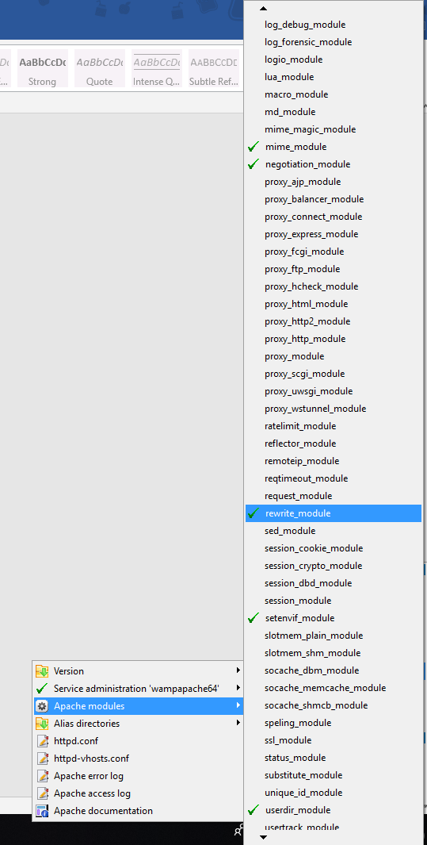

Left click on wamp icon > Apache > Apache Modules > scroll down and ensure that rewrite_module is enabled (green tick)

1. Change root directory of wamp to project folder

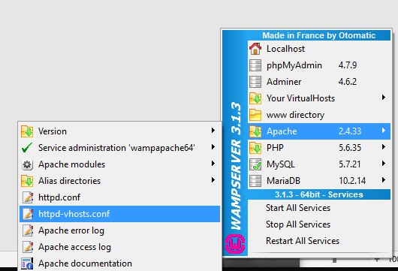

Left click on wamp icon > Apache > httpd-vhosts.conf

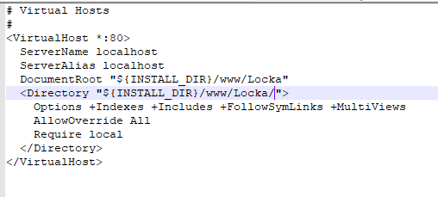

Change DocumentRoot and Directory to your project name (Mine is Locka so its as in image)

Save the file.

1. Restart all services

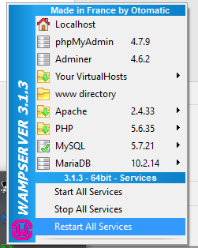

Left click on wamp icon > restart all services

1. Browse to localhost

All pages should now load properly